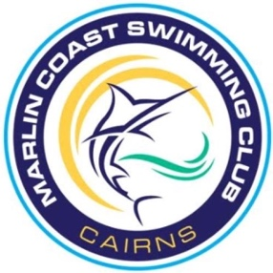

Marlin Coast Swimming Club Inclusivity Policy 2023

Marlin Coast Swimming Club recognises that inclusion is about making sure our club reflects the diversity of our local community and we are committed to working towards achieving this.

We commit to developing clear strategies and policies to achieve inclusion and remove discrimination within our club and we commit to establishing clear targets for measuring success.

We commit to promoting a safe, welcoming, and respectful culture where everyone feels welcome and accepted regardless of age, gender, ability, socio economic status or cultural, ethnic or religious background.

We commit to informing, supporting, and empowering our members and all others involved in Marlin Coast Swimming Club in relation to inclusion and diversity issues.

We commit to ensuring our sport activities consider the individual needs of participants and are appropriate to the level of development and skill. Where necessary we will make adaptations and modifications to cater for individual needs.

In making this commitment we recognise that our club has an important role to play in leading our community towards ensuring everyone has the chance to participate in swimming at the level and in the roles they choose.

Marlin Coast Swimming Club is a valuable part of our community. We have an opportunity to shape the culture of not only our club but the wider community by ensuring it is a welcoming, safe, and accessible club for all.

We follow, support, and uphold QLD Swimming Inclusive Swimming Framework.

https://qld.swimming.org.au/sites/default/files/assets/documents/InclusiveSwimmingFramework.pdf

